 | Sanjivani Rural Educational Society’s  SANJIVANI COLLEGE OF ENGINEERING  (An Autonomous Institution)  Kopargaon – 423 603, Maharashtra. | ACAD-F-15  K
Academic Year:  2025-26 | CIA ACTIVITY REPORT | Revision: 00 Dated:
Department: Information Technology | Information Technology | Date of  Preparation: 19-4-26
Course Code & Name: | PCIT208: Software Engineering Modeling & Design | Year/Sem: II  B.Tech Sem-I

Project Title:
Online Agriculture Management: With the advancement of technology, there is a need to modernize agricultural practices by adopting digital solutions. An Online Agriculture Management System is designed to provide a centralized platform where farmers can manage their activities efficiently.

Submitted by:

Roll No | PRN No | Name | Signature
151 | 0125UITF2002 | Gayatri Satish Sabale
152 | 0125UITF2007 | Pol Urmila Shashikant
153 | 0125UITF2009 | Daga Nupur Santosh
154 | 0125UITF2010 | Ghule Divya Sanjay
164 | 0125UITM2017 | Shelke Chaitanya Raju

Dr. S.N. Gunjal
Course Incharge
INDEX

Sr.No. | Topic | Page no.
 | Abstract | 3
 | Project Definition | 4
 | Introduction | 4
 | Scope of the Project | 5
 | Objectives of the Project | 5
 | Literature Review / Background Study | 6
 | System Analysis  7.1 Existing System  7.2 Problems in Existing System  7.3 Proposed System | 7
 | Software Requirements Specification (SRS)  8.1 Functional Requirements  8.2 Non-Functional Requirements  8.3 Use Case Diagram  8.4 Use Case Description | 8
 | System Design  9.1 UML Diagrams  - Class Diagram  - Sequence Diagram  - Activity Diagram  - Sate chart Diagram  - Component Diagram  - Deployment Diagram | 11
 | Data Flow Diagram (DFD) | 21
 | Control Flow Diagram (CFD) | 23
 | Conclusion | 24
 | References | 25

1. ABSTRACT

Agriculture is the backbone of the economy, yet many farming activities such as crop planning, resource management, market access, and record keeping are still handled manually. In the existing agriculture management system, farmers rely on traditional methods, local agents, and offline communication, which often results in lack of real-time information, poor decisionmaking, price exploitation, data loss, and limited access to government schemes. Although the current system is simple and familiar, it suffers from problems like inefficiency, lack of transparency, limited scalability, and minimal use of technology. To address these challenges, an Online Agriculture Management System is proposed. The proposed system provides a centralized, web-based platform that helps farmers manage agricultural activities digitally. It includes features such as farmer registration, crop details management, weather updates, fertilizer and pesticide recommendations, online marketplace access, government scheme information, and data storage. The system enables better planning, improves productivity, reduces dependency on intermediaries, and enhances communication between farmers, suppliers, and administrators. reduces manual effort, and enhances transparency.

CHAPTER 1
2. Project Definition

Agriculture activities are mostly managed using traditional and manual methods, which leads to inefficiency and lack of proper record keeping. Farmers depend on middlemen and offline sources for information, resulting in limited access to real-time data like weather updates, market prices, and government schemes.
The existing system lacks transparency, is time-consuming, and prone to errors and data loss. Due to this, farmers face difficulty in making informed decisions and often receive lower profits.
Hence, there is a need for a centralized online system that can manage agricultural activities efficiently, provide accurate information, and reduce dependency on intermediaries.

3.Introduction

Agriculture is the backbone of the economy and plays a crucial role in providing food and employment. However, many agricultural activities are still carried out using traditional methods, which limits efficiency and productivity. Farmers often face challenges such as lack of proper record management, limited access to real-time information, and dependency on intermediaries.
With the advancement of technology, there is a need to modernize agricultural practices by adopting digital solutions. An Online Agriculture Management System is designed to provide a centralized platform where farmers can manage their activities efficiently. It helps in maintaining crop records, accessing weather updates, getting recommendations, and connecting directly with markets.
This system aims to reduce manual effort, improve transparency, and support better decision-making, ultimately leading to increased productivity and better outcomes for farmers.

4. Scope of the Project
- The system supports farmer registration and crop management.
- It can be used by farmers, suppliers, and agricultural administrators.
- The system provides real-time information and data storage.
- It helps improve productivity and transparency in agriculture management

5. Objectives of the Project

- To provide an online platform for managing agricultural activities.
- To help farmers maintain crop and farm-related records digitally.
- To improve access to market information, weather updates, and schemes
- To reduce manual work and improve decision-making in agriculture.

CHAPTER 2

6. Literature Review
SR NO | TITLE | AUTHOR | PUBLISHED YEAR | METHODOLOGY
1 | Smart Agriculture System using IoT | M. Patel et al. | 2019 | Used IoT sensors to monitor soil moisture, temperature, and crop conditions in real time.
2 | IoT Based Smart Farming System | Shreya Kulkarni et al. | 2020 | Sensors and cloud platform used for data collection and analysis.
3 | Smart Farming using Machine Learning | A. Verma et al. | 2022 | Applied machine learning algorithms for crop prediction and disease detection.
4 | Cloud-Based Agriculture System | S. Gupta et al. | 2021 | Used cloud computing for storing and processing agricultural data.
5 | Online Agriculture Marketplace System | K. Reddy et al. | 2023 | Developed platform for direct buying and selling of crops online.

CHAPTER 3

7. System Analysis
7.1 Existing System
- Manual record keeping
- Dependence on middlemen
- Limited access to market prices
- No centralized data system
- Offline communication

7.2 Problems in Existing System
- Lack of transparency
- Data loss risk
- Time-consuming processes
- Poor decision-making
- Limited scalability

7.3 Proposed System
- Web-based centralized system
- Real-time updates (weather, market)
- Digital record management
- Direct farmer-to-buyer interaction
- Improved transparency and efficiency

CHAPTER 4
8. Software Requirements Specification (SRS)
8.1 Functional Requirements
FR1: The system shall allow farmers to register by providing personal and farm details.
FR2: The system shall allow registered users to log in using valid credentials.
FR3: The system shall allow farmers to add, update, and delete crop details.
FR4: The system shall provide real-time weather updates to users.
FR5: The system shall provide recommendations for fertilizers and pesticides.
FR6: The system shall allow farmers to view and access market prices of crops.
FR7: The system shall provide an online marketplace for buying and selling agricultural products.
FR8: The system shall display information about government schemes related to agriculture.
FR9: The system shall allow administrators to manage user accounts.
FR10: The system shall allow administrators to update system data such as schemes, prices, and recommendations.

8.2 Non-Functional Requirements
NFR1 (Performance): The system shall respond to user requests within a reasonable time.
NFR2 (Security): The system shall ensure secure login and protect user data from unauthorized access.
NFR3 (Usability): The system shall provide a user-friendly interface for easy navigation.
NFR4 (Reliability): The system shall operate without failure under normal conditions.
NFR5 (Scalability): The system shall support an increasing number of users without performance degradation.
NFR6 (Availability): The system shall be available to users at all times except during maintenance.
NFR7 (Maintainability): The system shall be easy to maintain and update.
NFR8 (Compatibility): The system shall be accessible on different devices such as mobile, tablet, and desktop.

CHAPTER 5

8.3 Use Case Diagram
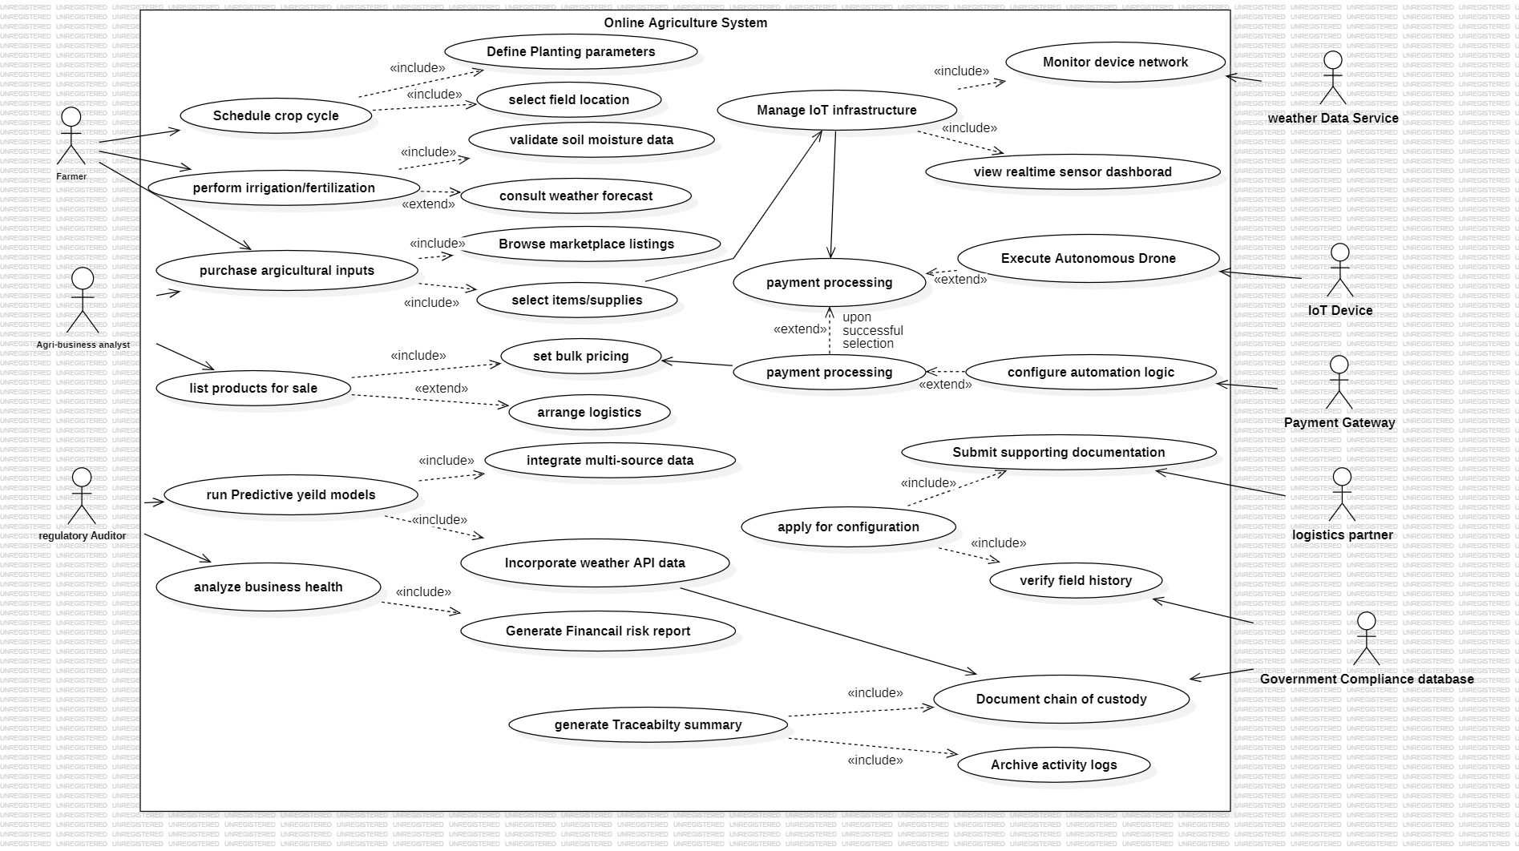
8.4 Use Case Discription
- Schedule Crop Cycle: Defines crop planning based on field conditions and soil data.
Perform Irrigation/Fertilization: Manages watering and fertilizing using environmental and weather inputs.
- Purchase Agricultural Inputs: Enables buying of seeds, fertilizers, and other supplies through the system.
- List Products for Sale: Allows users to publish agricultural products with pricing details.
- Arrange Logistics: Handles transportation and delivery of sold products.
- Run Predictive Yield Models: Estimates crop yield using historical and real-time data.
- Analyze Business Health: Evaluates financial performance and risks of agricultural activities.
- Manage IoT Infrastructure: Monitors and controls connected farming devices and sensors.
- View Real-time Sensor Dashboard: Displays live data from field sensors.
- Monitor Device Network: Tracks the status and performance of IoT devices.
- Execute Autonomous Drone: Performs automated farming operations using drones.
- Configure Automation Logic: Defines rules for automated farming actions.
- Apply for Configuration: Submits requests for system setup or approvals.
- Submit Supporting Documentation: Provides required documents for verification processes.
- Verify Field History: Checks historical data of the agricultural field.
- Payment Processing: Handles secure transactions for purchases and services.
- Integrate Multi-source Data: Combines data from various sources for analysis.
- Incorporate Weather API Data: Uses weather data for better decision-making.
- ⁠Generate Financial Risk Report: Produces reports on financial risks and stability.
- ⁠Generate Traceability Summary: Creates records of product lifecycle for transparency.
- ⁠Document Chain of Custody: Tracks movement and ownership of agricultural products.
- ⁠Archive Activity Logs: Stores system activities for auditing and compliance.

9.System Design
9.1 UML Diagrams

- Class Diagram
A Class Diagram is a type of diagram used in object-oriented design that shows the structure of a system by representing classes, their attributes (data), methods (functions), and the relationships between them. in simple words, it shows how different parts (classes) of a system are organized and connected.

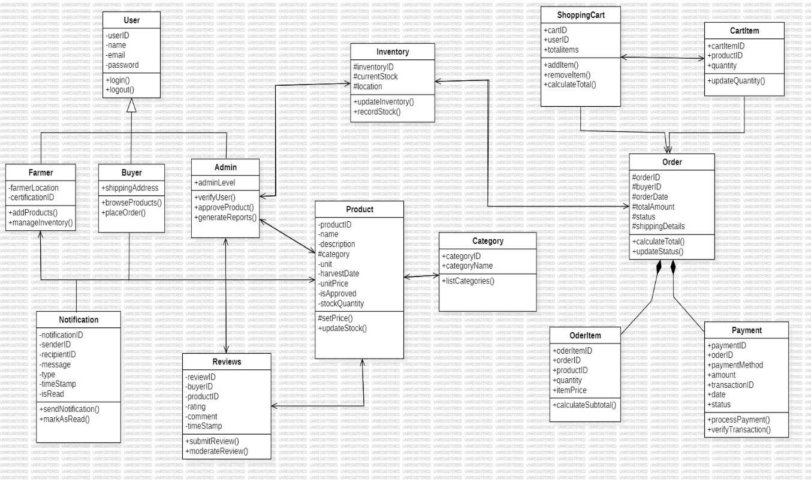

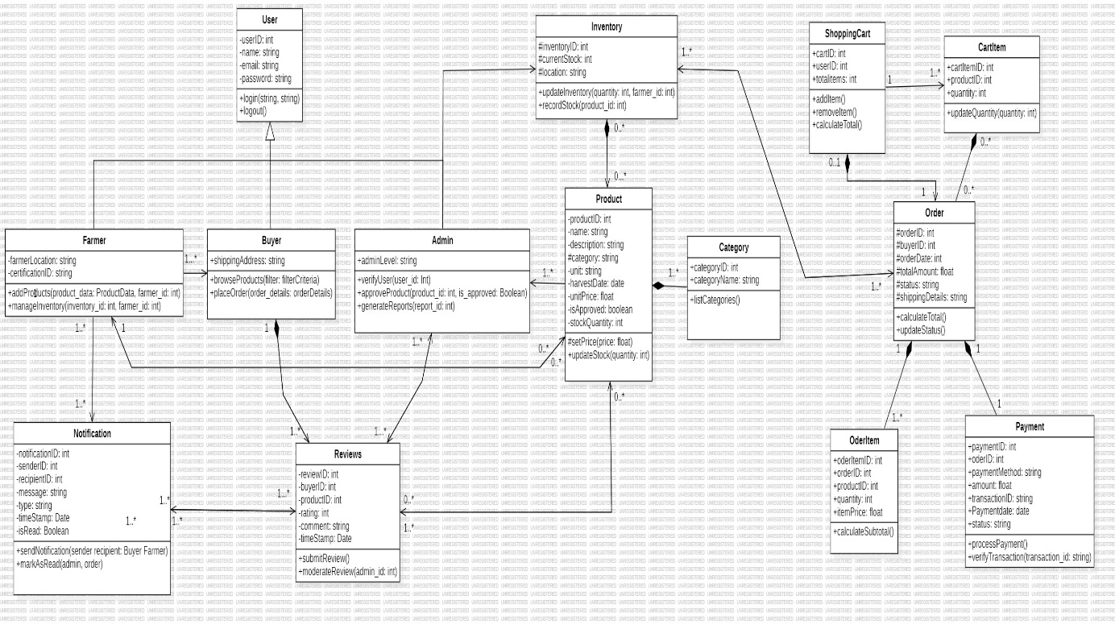

- Sequence Diagram
A Sequence Diagram is a type of diagram in system design that shows how different objects or components interact with each other in a particular order over time.in simple words, it explains the step-by-step flow of messages or actions between different parts of a system to complete a task.

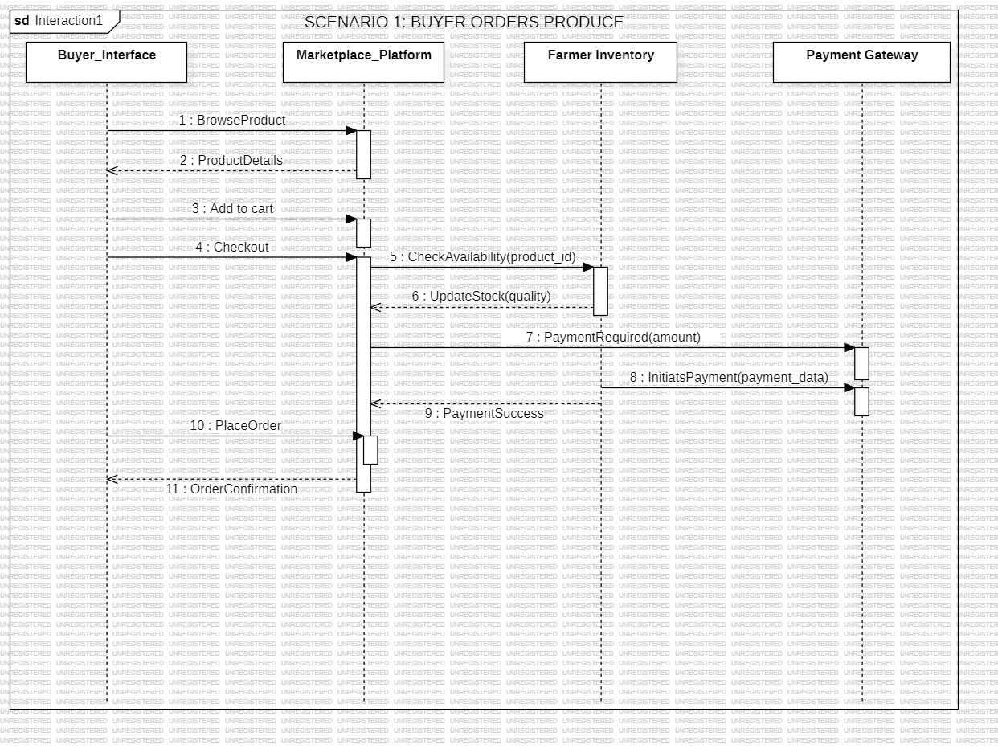

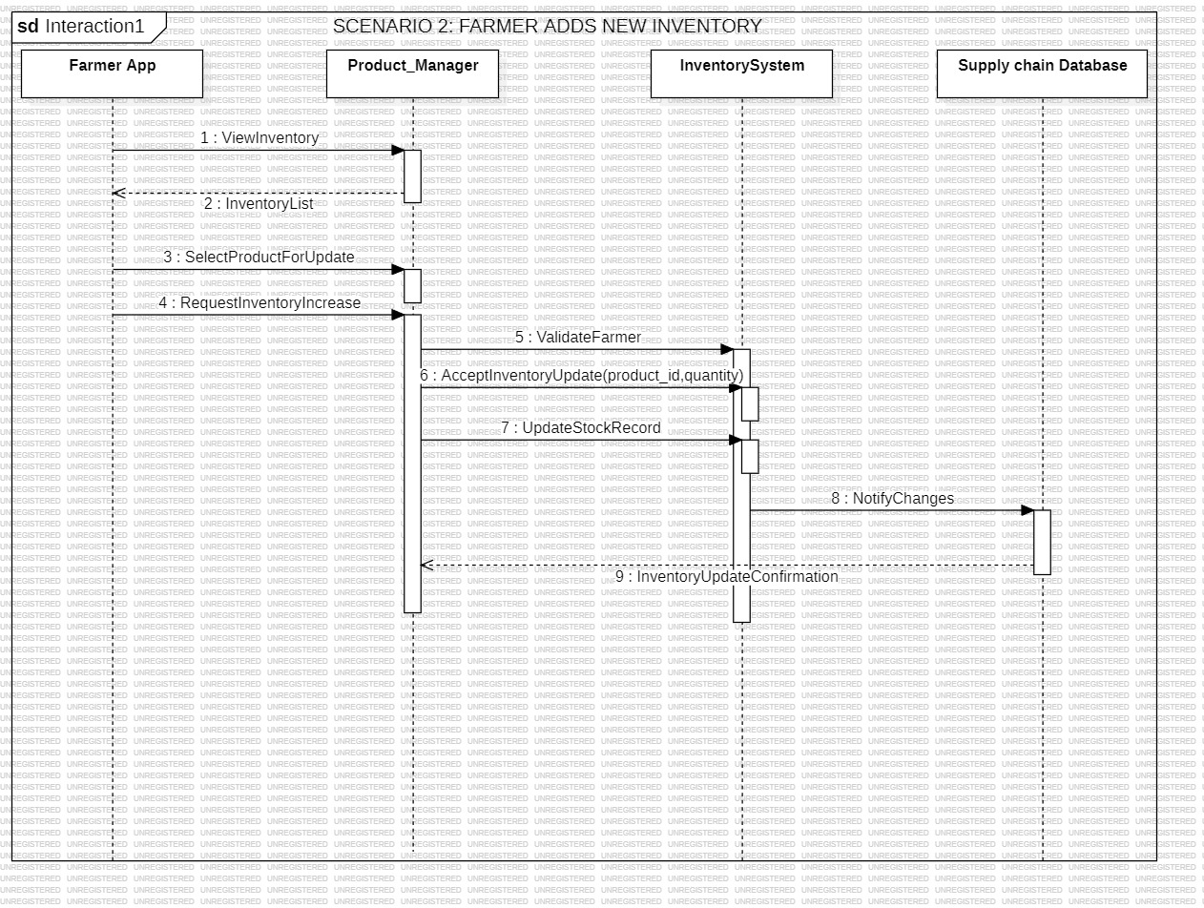

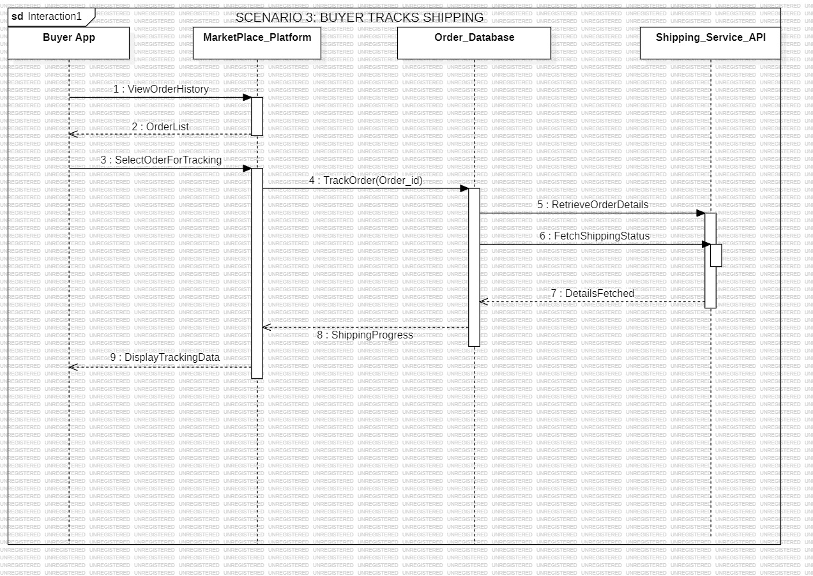

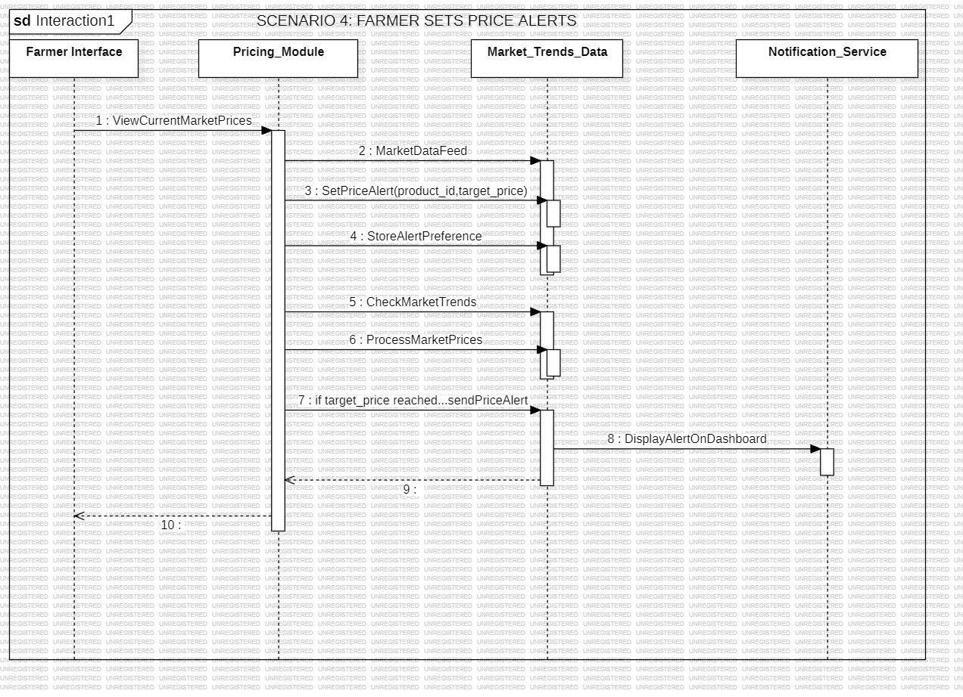

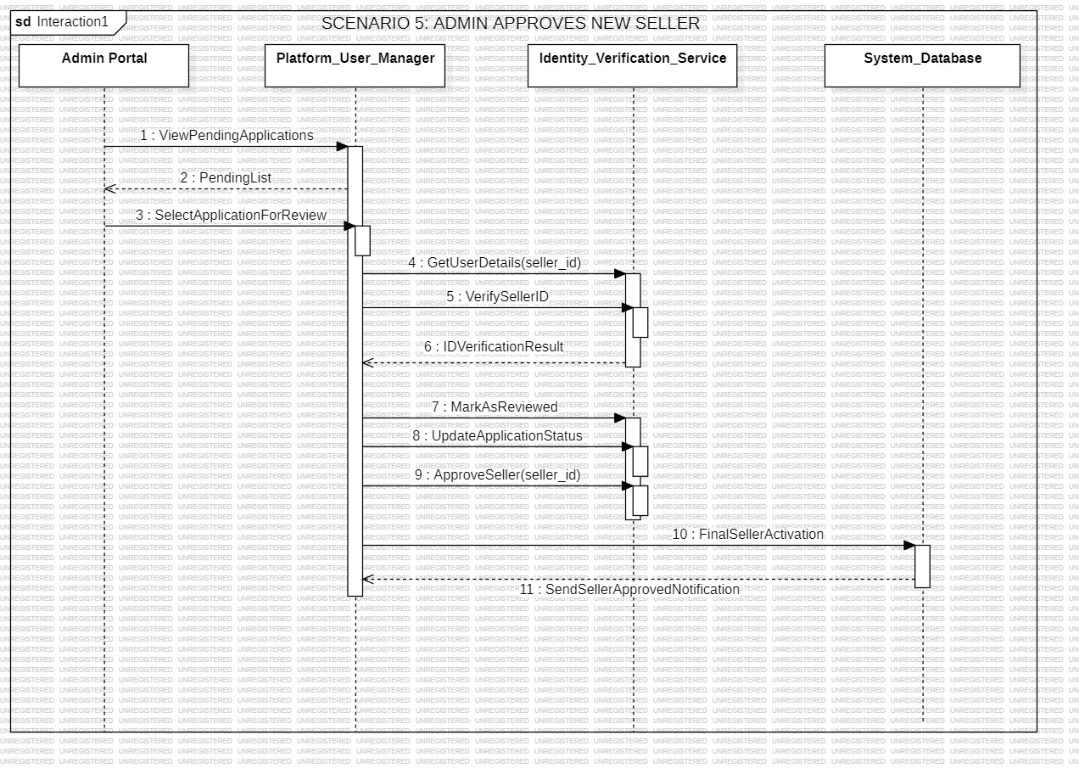

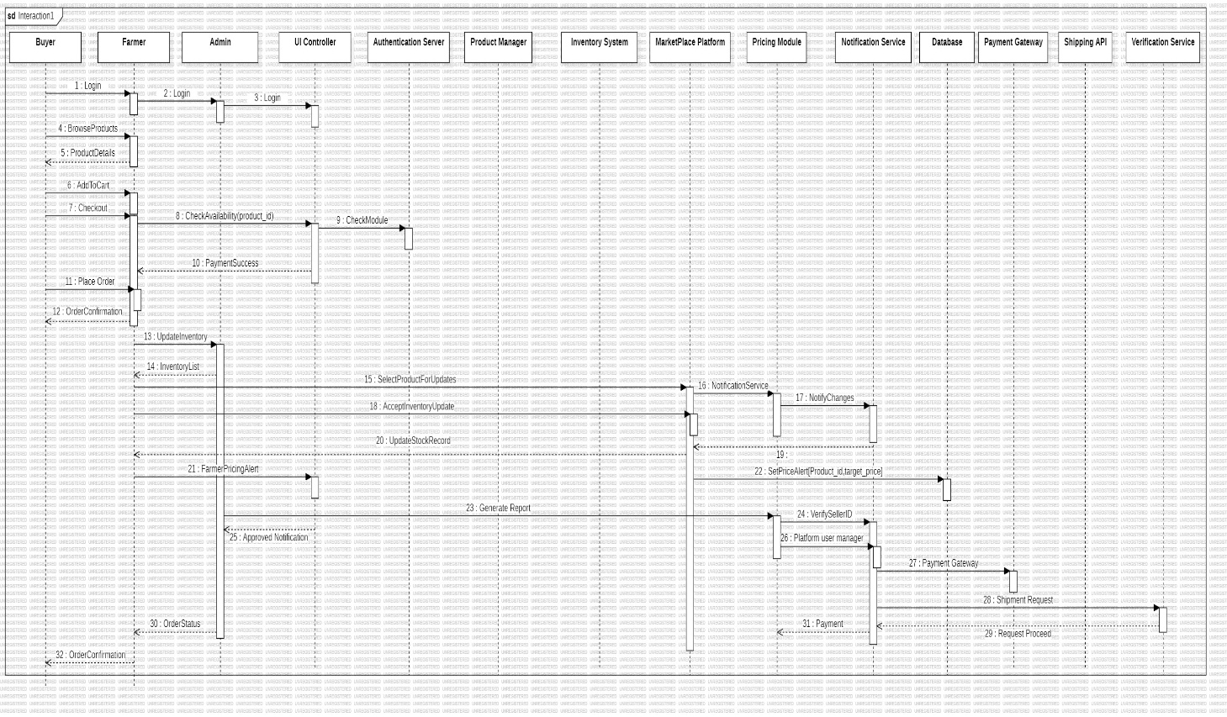

- Activity Diagram
An Activity Diagram is a type of UML diagram that represents the flow of activities or steps in a process from start to end. It shows how different actions are performed, including decision points, parallel activities, and the sequence of operations. in simple words, it explains the step-by-step workflow of a system or process.
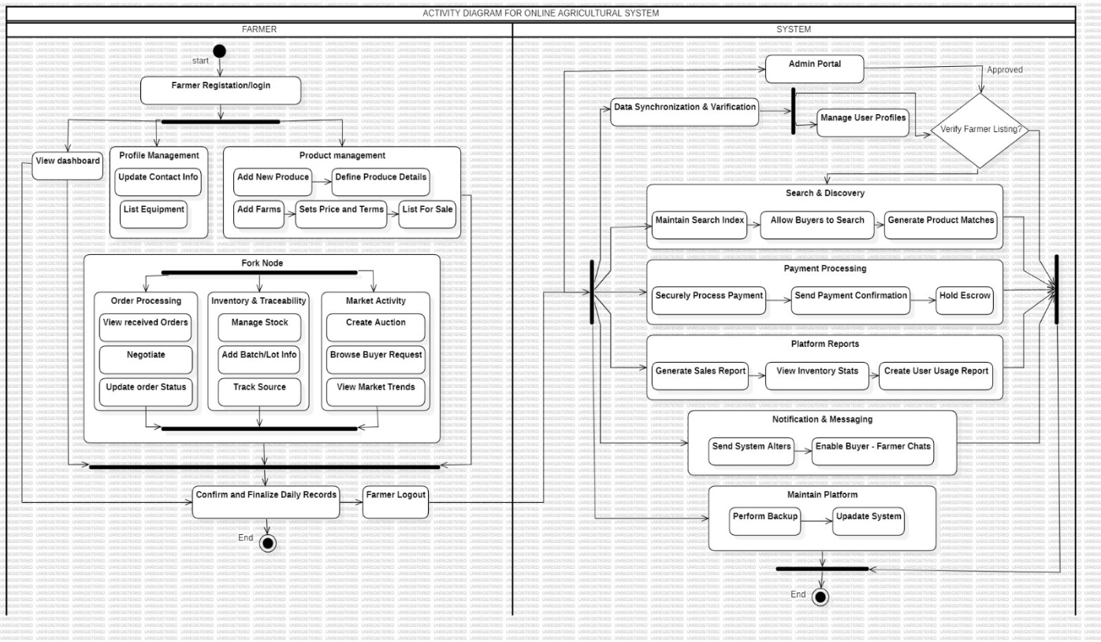
- Sate chart Diagram
A State Chart Diagram (also called a State Machine Diagram) is a type of UML diagram that shows the different states of a system or object and how it changes from one state to another based on events. in simple words, it describes how a system behaves at different stages and how it moves between states over time.

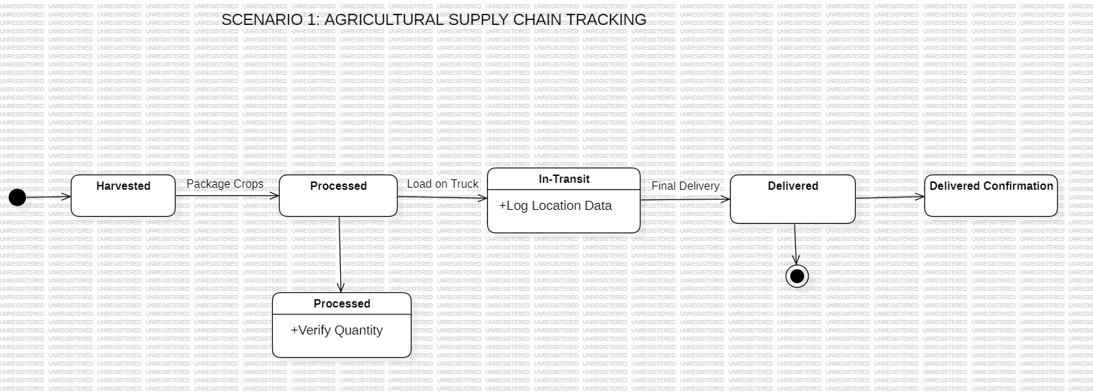

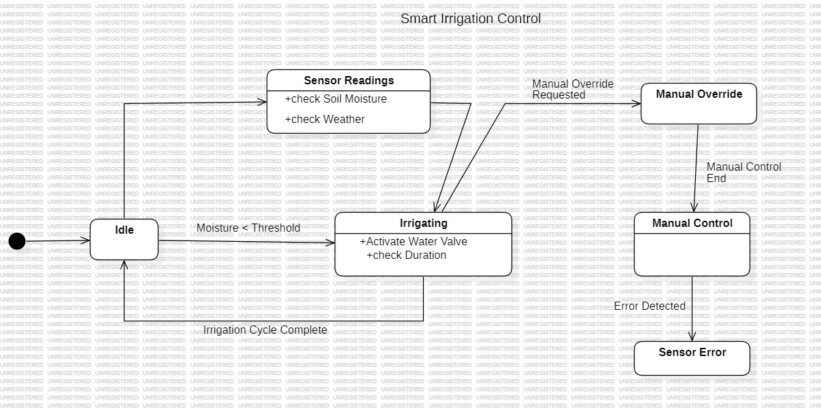

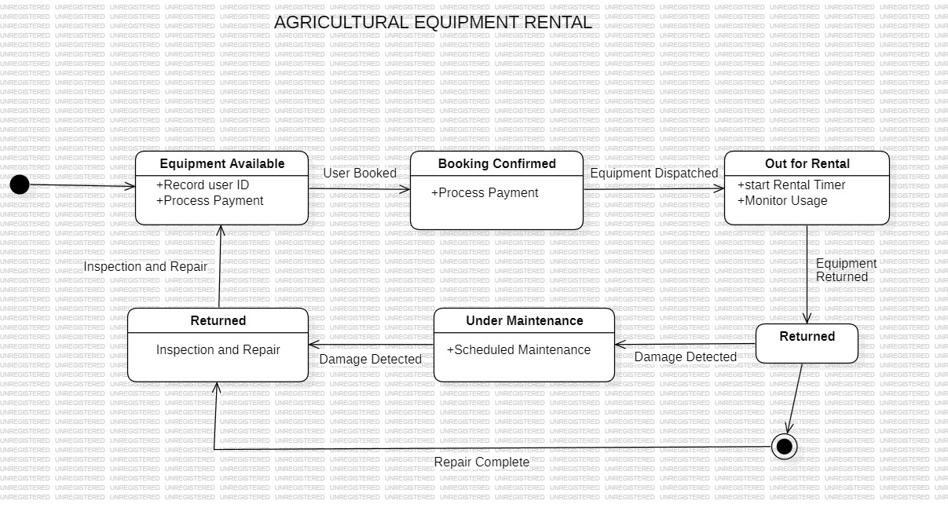

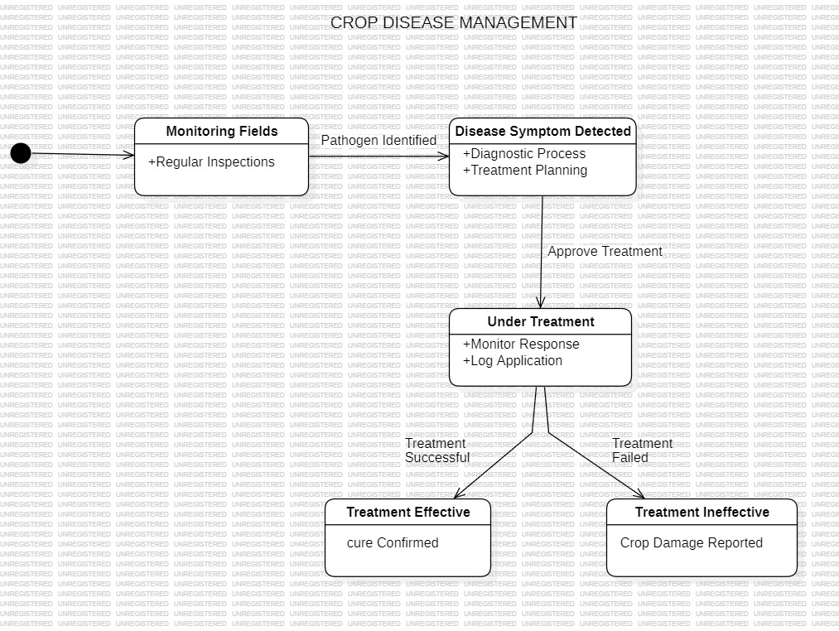

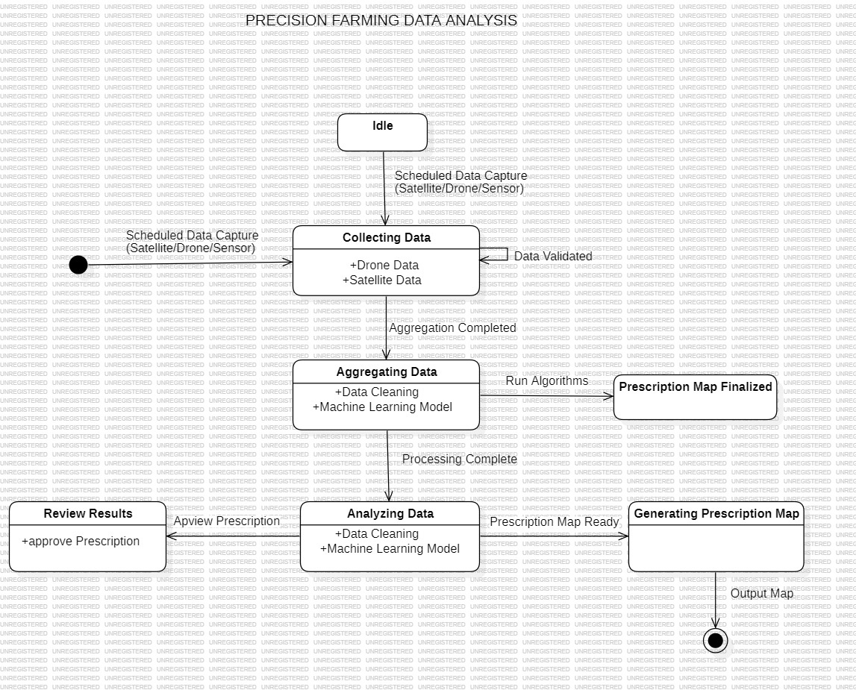

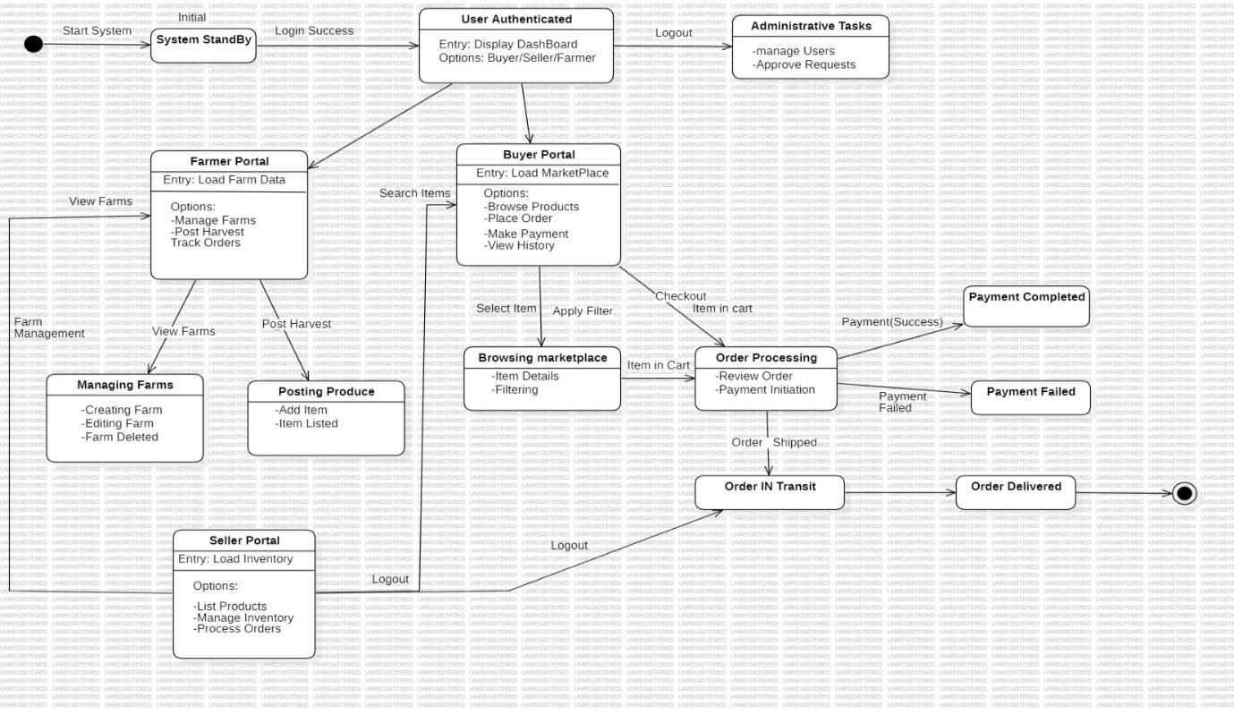

- Component Diagram
A Component Diagram is a type of UML diagram that shows the different components (modules) of a system and how they are connected or interact with each other. in simple words, it represents the structure of a system by dividing it into smaller parts and showing their relationships

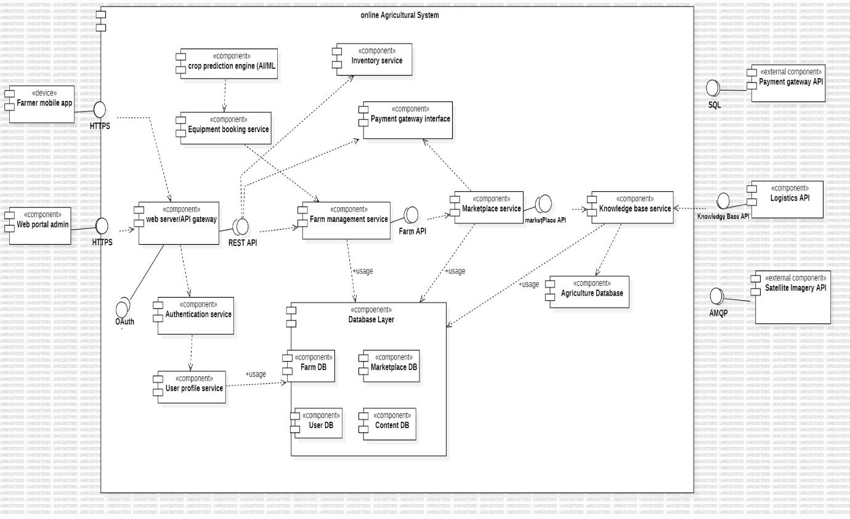

- Deployment Diagram
A Data Flow Diagram (DFD) is a graphical representation that shows how data moves through a system. It illustrates the flow of information between inputs, processes, data stores, and outputs. in simple words, it explains where data comes from, how it is processed, and where it goes.

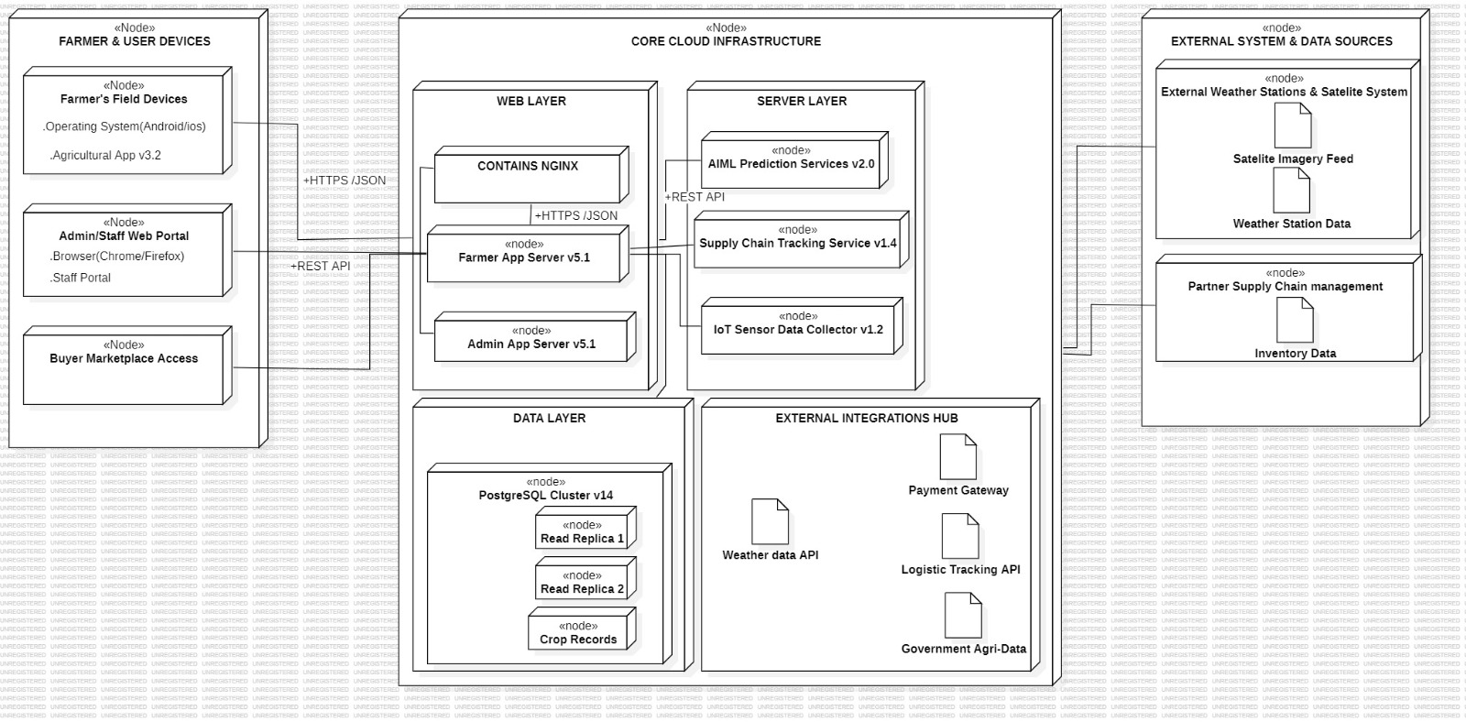

CHAPTER 6
10. Data Flow Diagram (DFD)
A Data Flow Diagram (DFD) is a graphical representation that shows how data moves through a system. It illustrates the flow of information between inputs, processes, data stores, and outputs. in simple words, it explains where data comes from, how it is processed, and where it goes.

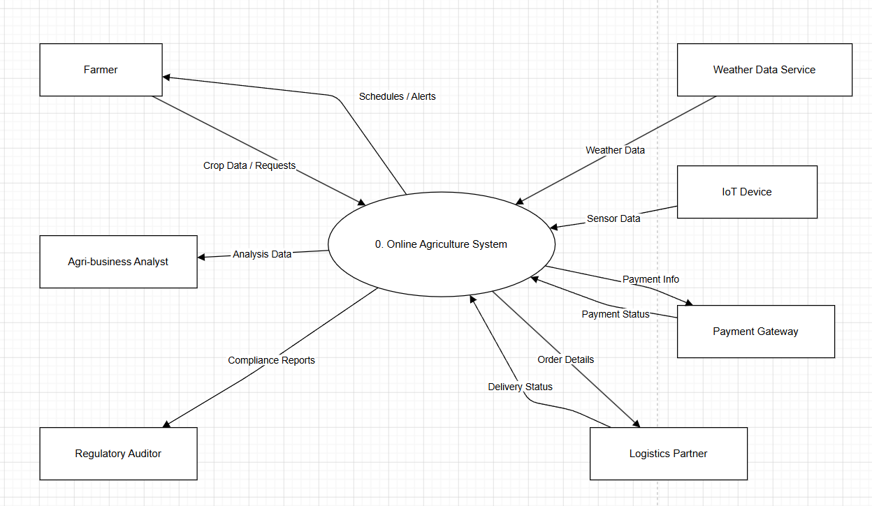

Fig. DFD 0 level

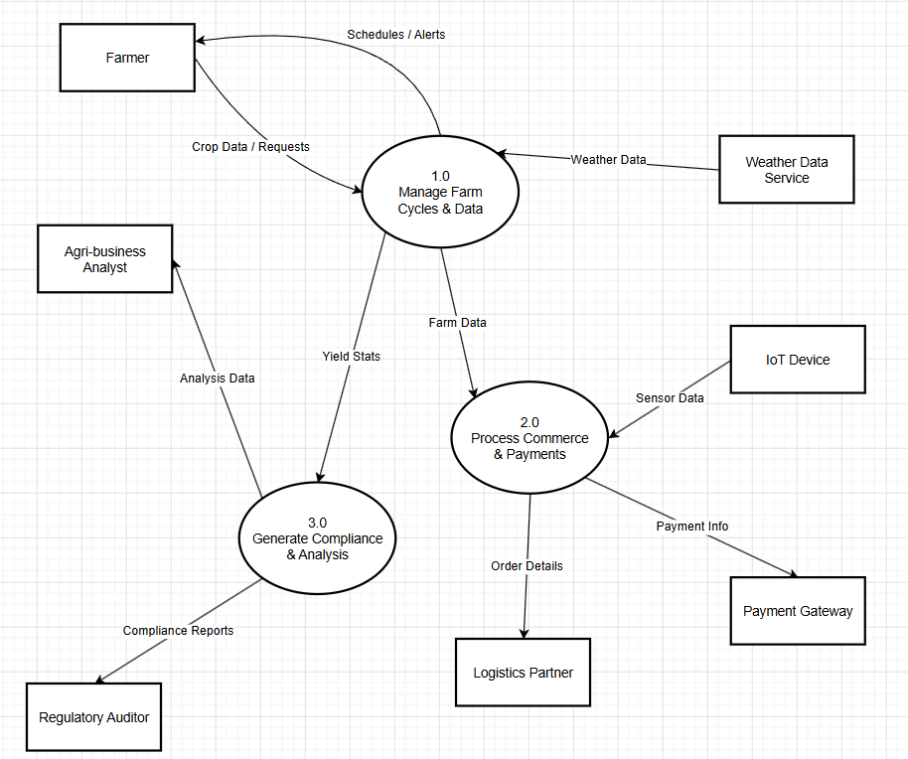

Fig. DFD 1 level

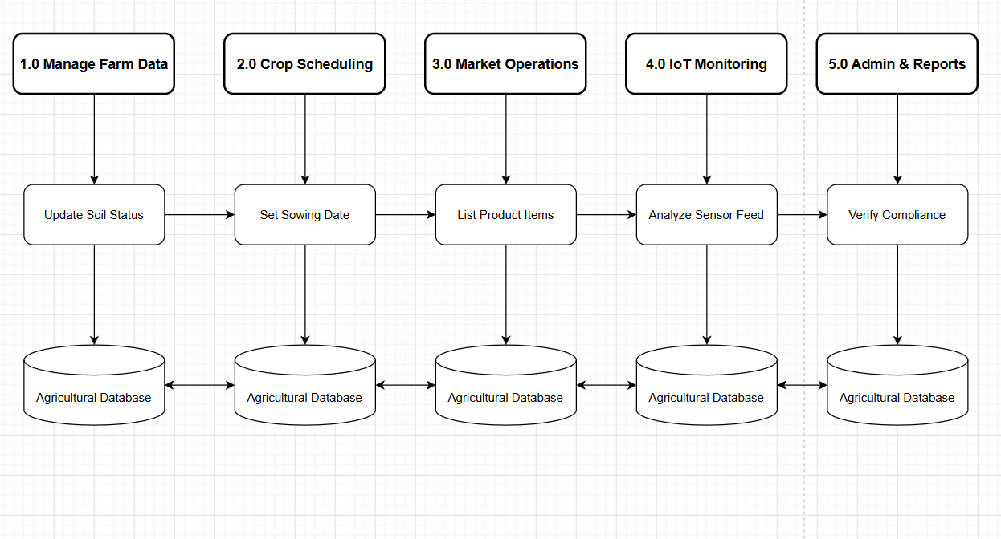
Fig. DFD 2 level

CHAPTER 7
11.Control Flow Diagram (CFD)

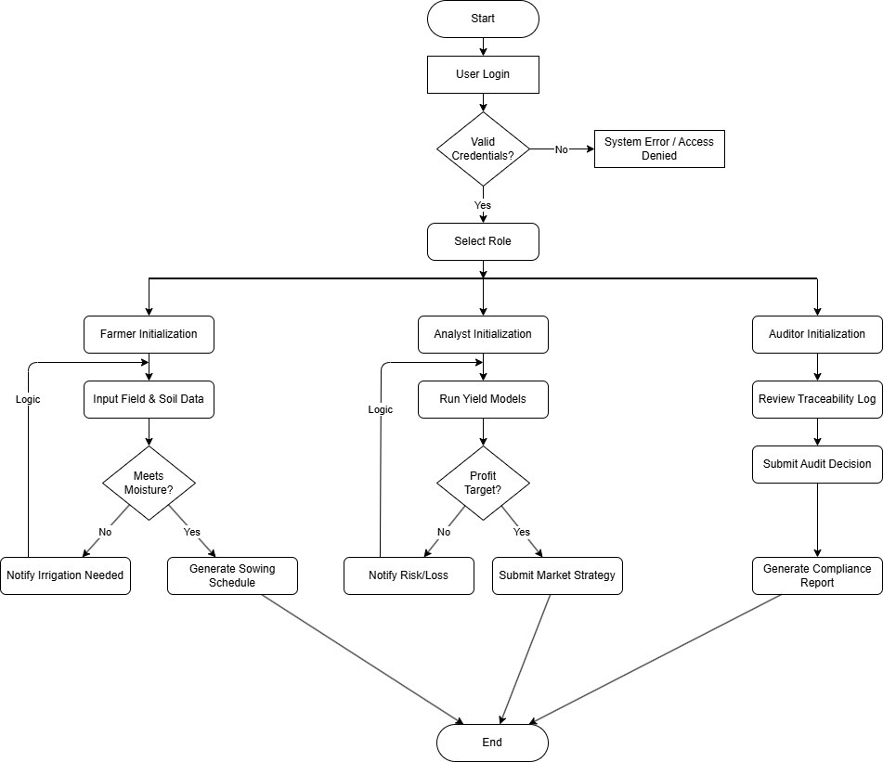

Fig. Control Flow Diagram

CHAPTER 8

12.Conclusion

The Online Agriculture Management System provides an effective solution to the problems faced in traditional farming methods. By digitizing agricultural activities, the system helps farmers manage their data efficiently, access real-time information, and reduce dependency on intermediaries.
The system improves transparency, reduces manual effort, and supports better decision-making. Features such as crop management, weather updates, marketplace access, and government scheme information make the system highly useful for farmers.
Overall, this project contributes to modernizing agriculture by integrating technology, leading to improved productivity, better resource management, and increased farmer satisfaction.

CHAPTER 9

13.References
1. Sommerville, I. Software Engineering, 10th Edition, Pearson Education.
2. Pressman, R. S. Software Engineering: A Practitioner’s Approach, McGraw-Hill.

3. Elmasri, R. and Navathe, S. B. Fundamentals of Database Systems, Pearson.
4. Object Management Group (OMG), Unified Modeling Language (UML) Specification.

5. IEEE, Software Requirements Specification (SRS) Standards.

6. Research papers and articles on Online Agriculture Management.

